Triggering control of singular systems | Funnel control of sampled-data/discrete-time systems
Q1. Why K could not be continuously updated on triggering period for smaller gain.  K too high is no good at all.  Q2. Detect the triggering point based on norm, why not pointwise? Change the norm 2 to norm 1?  Q3. Code triggering nonlinear?  Q4. For delay systems  Q5. CUMSUM | Q1. Funnel control for nonlinear system. Application in electronic.  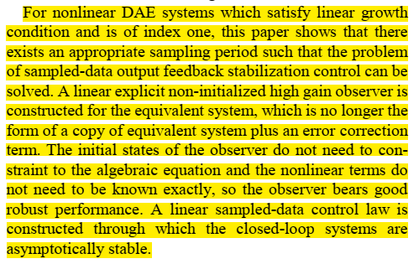  Same question for funnel control.  Q2. Power systems is hot again, see a Triet.  Verghesse got 312 citations, some of them are quite recent.  Milano

